Models:
- Crypto Setup
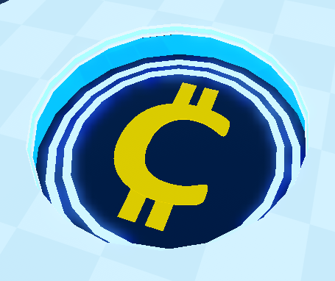

That’s the crypto logo: forget about the blue background but the yellow C is the logo.
We need a crypto themed setup but not the pc for now.
So make the setup crypto themed of course, with a black version of that crypto logo, with yellow/orange themed monitor and mouse and keyboard.

- PC and Setup for Tech shop
This would be a spaced themed setup, so rockets, planets, black holes whatever you can think of, it will be the 11th setup, so above this one: 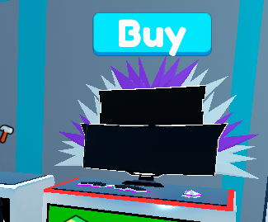
So make it cool.
- Chains for the NFT Stands
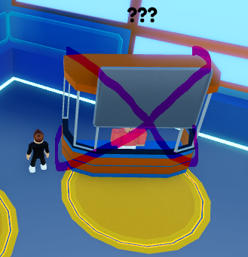

Make Chains for the NFT stands that haven’t been unlocked yet. Grey chains that cross at the back and the front (so you can see them from the back as well). Ask us if you need the NFT stand model.
- Relativity Ring Quantum Artifact
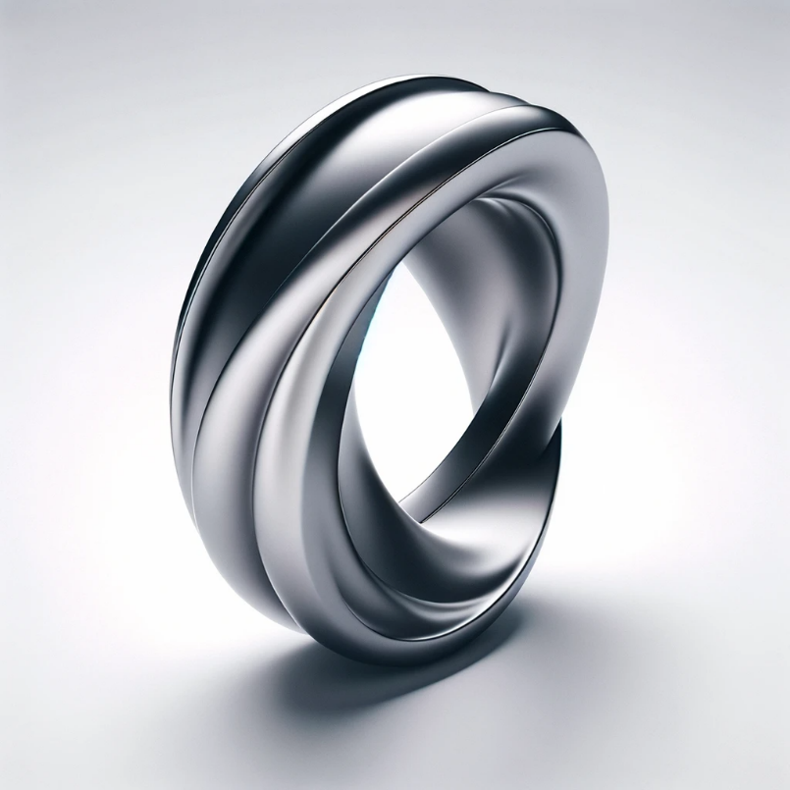
- Infinity Necklace Quantum Artifact
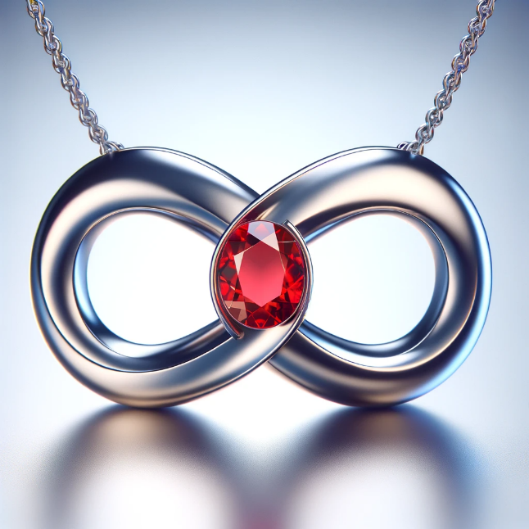

Make sure to keep the chain of the necklace somehow

